Project Portal:

Task 3

Daniel Card

CSCE470 – Capstone Project

Adriano Cavalcanti

March 4, 2015

Supervisor:

Dr. Kenrick Mock

kenrick@uaa.alaska.edu

Contents

3 Design and Testing / User Interface 1

3.1 System Design 1

3.2 User Interface 2

3.3 Testing 6

4 References 7

4.1.1.1.1.1.1 4.1.1.1.1.1.1-1

4.1.1.1.1.1.2 4.1.1.1.1.1.2-1

Figure 3.1 – Example of simple web design (nest.com) 2

Figure 3.2 – Image of Project Portal’s landing page 3

Figure 3.3 – Image of Project Portal’s map page 4

Figure 3.4 – Image of Project Portal’s file page 5

Figure 3.5 – Image of Project Portal’s calendar page 6

# Design and Testing / User Interface

## System Design

Project Portal’s design was created around the idea of simplicity. Besides the idea of simplicity, the design of the project was largely influenced by the specifications I was given for the project. The project specifications were wrapped around the concept of simplicity. I was told that this application was going to be a team collaboration tool. Each tool would need to make communicating and accessing project information very easy. If the application is not simple and easy to use then team members will not use it and creating the application would be a waste of valuable time and resources. Because Project Portal is actually going to be used by teams working on various projects, it was important to get the design correct while giving it the flexibility to adapt to each unique project.

In a study by Google in August of 2012, researchers found that not only will users judge websites as beautiful or not within 1/50th – 1/20th of a second, but also that “visually complex” websites are consistently rated as less beautiful than their simpler counterparts. Moreover, “highly prototypical” sites – those with layouts commonly associated with sites of it’s category – with simple visual design were rated as the most beautiful across the board. In other words, the study found the simpler the design, the better. [1]

The design requirements specified at the inception of Project Portal compact down into three main elements. The elements are a map, a calendar, and a place to share files. Those are the main requirements, however the project necessarily grew to include a landing page and a security login.

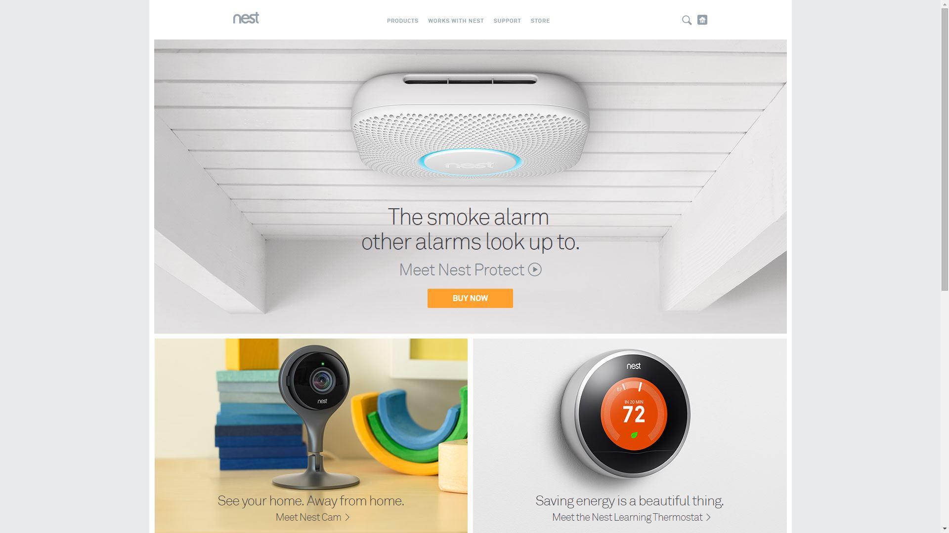

Figure 3.1 – Example of simple web design (nest.com)

## User Interface

The user interface follows closely to the over-arching system design concept of simplicity. I tried to make all the elements on each page simple and intuitive. Simplicity is a basic principle of UI design. The simpler a user interface, the easier it is to use. But keeping user interfaces for business applications simple is a challenge because the apps often have a lot of functionality. The key is to balance functionality and simplicity. Restraint is one of the most efficient ways to achieve this balance: i.e. finding the simplest way to solve a problem. [2] Using the Twitter bootstrap, I was able to achieve the modern look and feel I wanted.

All of the displayed pages have several features in common. They all contain a small State of Alaska header bar. The header bar allows for the State of Alaska branding of the page as well as links to the Department of Natural Resources’ and State of Alaska’s homepages. Using a header bar was a requirement that I was given. Each page also incorporates a navigation bar with links to all the pages. The navigation bar additionally includes a project title which can be changed based on the project, but is Project Portal in this example. When the user has logged in through the security login, there is a welcome message that includes the user’s username displayed in the navigation bar. On the bottom of each page there is a footer

The landing page is the first page the user sees. It contains a welcome message to the user and a large project related image. There is a single button at the bottom of this page. The button takes the user to the security login page.

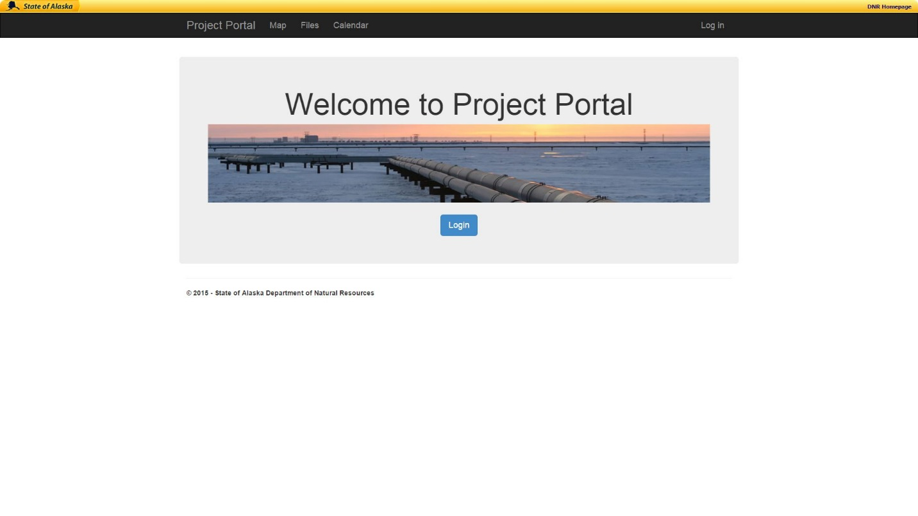

Figure 3.2 – Image of Project Portal’s landing page

The next page a user will see is the login page. It contains a simple for asking for the username and password of the user, which are the same as their LDAP (Lightweight Directory Access Protocol) security credentials. All state employees are given LDAP credentials when they are hired. Outside contractors and other users may be given LDAP credentials if necessary. Before the user logs in the only have access to the landing page and the login page. Once the user logs in, then they have access to the pages.

The map page primarily consists of a large color map. On the left side of the map is a legend pane that allows the user to select the layers to be displayed on the map. In the legend pane, checkboxes are used as a visual indicator to the user which elements are being displayed. The map itself has controls for zoom and also allows for panning.

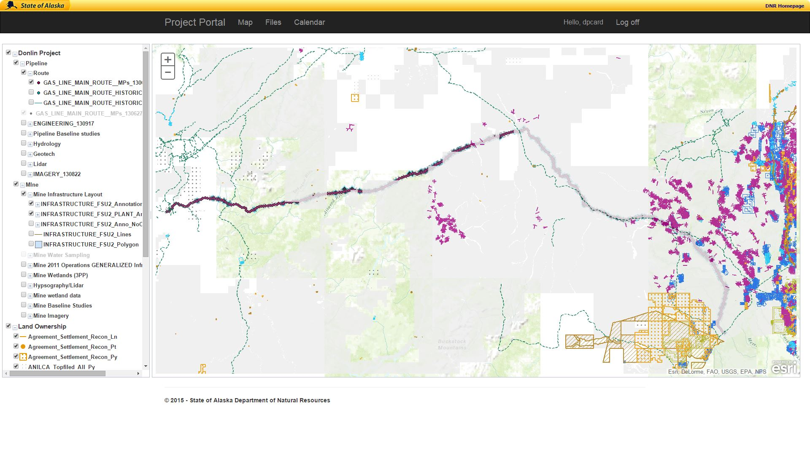

Figure 3.3 – Image of Project Portal’s map page

The file page contains a file browser. On the left side of the file browser is a folder tree that not only displays to the user their location but allows them to relocate themselves by clicking a different folder. In the larger box to the right of the folder tree, the files and directories within the selected folder are displayed. If the user right clicks in the in the content display window they will get a menu with items typically seen within a file browser such as open, delete, rename.

Above the folder and file display panes is a toolbar. The tool bar has buttons to move forward and backwards. It also contains buttons to manipulate folders. There is one for opening a folder, adding a new folder, deleting a folder, and refreshing the folder contents display. Buttons for changing how the contents of how the files and folders are displayed such as in a list or in thumbnails are also in the toolbar. All of the buttons on the toolbar use easily recognizable icons so that users identify which button they need. The buttons also have tooltips if the user hovers their mouse over the button.

The final button available on the toolbar is a button for uploading files. When the button is clicked a small window pops up with options for uploading files. The window also displays the maximum file size and the allowed file types to the user.

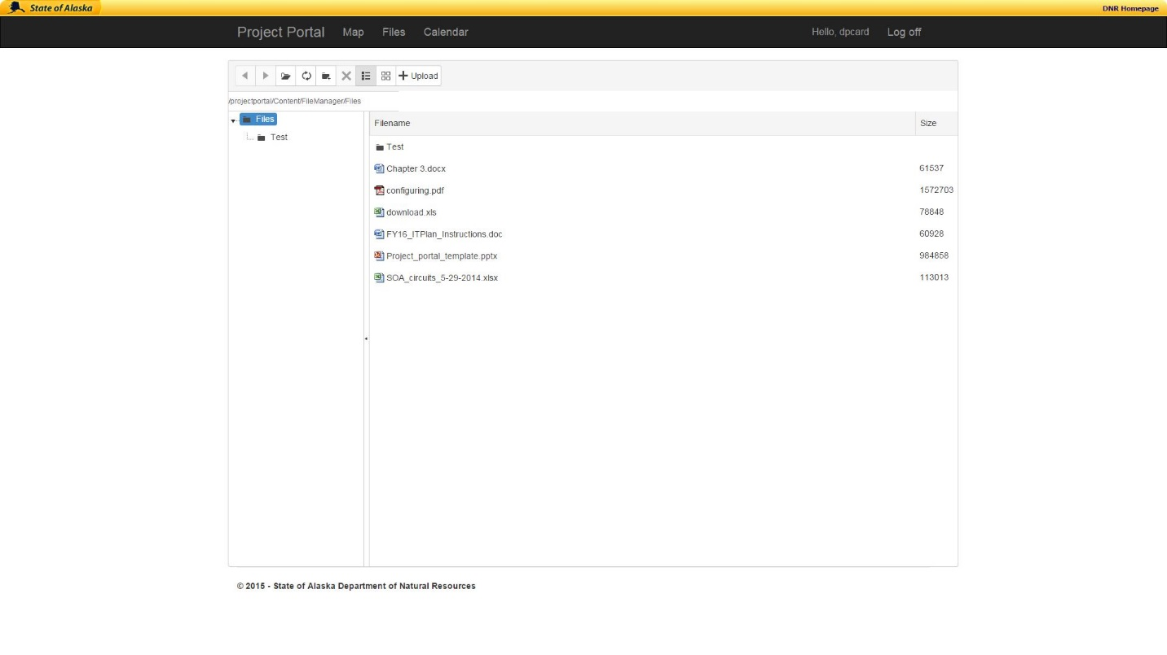

Figure 3.4 – Image of Project Portal’s file page

The calendar page displays a calendar similar to a calendar you would find bundled with your email program within the main box. Above the main box is a toolbar with controls for the calendar. On the left-side of the toolbar are buttons for forwards and backwards navigation as well as a datepicker to jump directly to a date. On the right-ide of the toolbar are buttons to change the view. The view can be changed to display a day, a week, a month or a timeline. In the timeline view the calendar displays a chronological list of appointments by day.

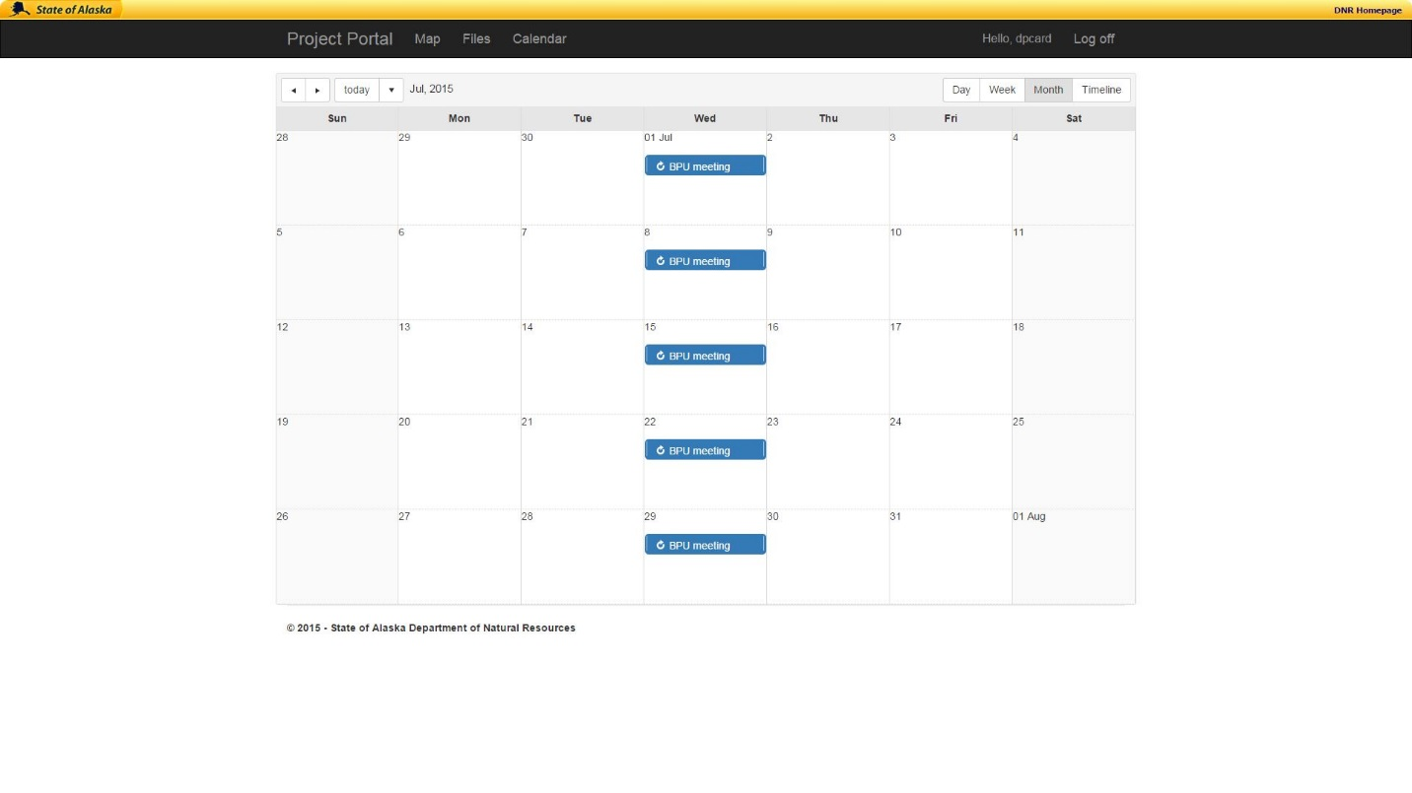

Figure 3.5 – Image of Project Portal’s calendar page

## Testing

Testing is a very important part of the software development process. Testing is designed to reveal errors and defects within the program. Constructing quality products continues to be one of software development’s greatest challenges. Testing, one of the most crucial tasks along the software development life cycle, can easily exceed half of a project’s total effort. A successful testing approach can save significant effort and increase product quality, thereby increasing customer satisfaction and lowering maintenance costs. [3]

Project Portal primarily uses the agile testing methodology. This methodology is used for all the testing including system testing and acceptance testing. The premise of agile testing is that we are doing testing at the same time as we are developing.

The first test type of testing that was used is unit testing. In unit testing, the program is separated into small parts or units. Each unit is tested on an individual level using a variety of inputs and environments in order to make sure the program operates correctly and as required. For Project Portal, I split the project into units based on the logical separation of pages. For example, the login page was a test unit. I created a test for each part of the test unit that tested the functionality of each piece within the test unit. Unit testing is mainly done during the early stages of the software development process.

The second type of testing used by Project Portal was system testing. The primary idea being system testing is to test the entire program as one complete unit. System testing is considered a black box test. This means that the person testing does not need to have any understanding of how the program works, all they need to know is what to input and what output to expect.

The final type of testing used by Project Portal was user acceptance testing. User Acceptance Testing (UAT) - also called beta testing, application testing, and/or end user testing - is a phase of software development in which the software is tested in the "real world" by the intended audience or a business representative. Whilst the technical testing of IT systems is a highly professional and exhaustive process, testing of business functionality is an entirely different proposition. [4] User acceptance testing includes testing the system both for its functionality as well as if it meets the project requirements. Typically, user acceptance tests are the last tests done on the program before it is released.

Using all of these different types of tests during the project development, allowed me to test the program at various levels. This was a very comprehensive testing methodology. While more testing could have been done, I believe the testing adequately covered the program in order to find the bugs and missing features. The customer was the final person to complete testing on the program therefore if the customer was satisfied that the program meet the requirements and was error free, then the program should be considered complete.

### Agile

Agile programming is based off the agile manifesto. The basics of the manifesto come down to being flexible in both project design as well as customer interaction. Agile programming accomplishes the main tenets by using several practices such as test-first programming, frequent refactoring, and continuous integration.

Agile project management is also built upon the agile manifesto. While agile programming focuses on using agile techniques to accomplish the agile methodology. Agile project management focuses on the project as a whole. Agile project management lets software project managers and employees alike adapt to changing circumstances, rather than try to impose rigid formal controls, as in traditional linear development methods. [5] The main keys to agile project management are to increase customer communication, flexibility, and delivery of a quality product within the shortest amount of time possible.

# References

|  |  |
| --- | --- |
| [1] | T. Walker, "Why simple websites are scientifically better," ConversionXL, 2015. [Online]. Available: http://conversionxl.com/why-simple-websites-are-scientifically-better/. [Accessed July 2015]. |
| [2] | J. Jovanovic, "Designing User Interfaces For Business Web Applications," Smashing Magazine, 25 February 2010. [Online]. Available: http://www.smashingmagazine.com/2010/02/designing-user-interfaces-for-business-web-applications/. [Accessed 07 2015]. |
| [3] | N. Juristo, A. M. Moreno and W. Strigel, "Software Testing Practices in Industry," *IEEE Software,* vol. 23, no. 4, pp. 19-21, 2006. |
| [4] | V. Bordo, "Overview of User Acceptance Testing (UAT) for Business Analysts (BAs)," Developmentor, [Online]. Available: https://www.develop.com/useracceptancetests. [Accessed July 2015]. |
| [5] | S. Augustine, B. Payne, F. Sencindiver and S. Woodcock, "Agile project managment: Steering from the edges," *Communications of the ACM,* vol. 48, no. 12, pp. 85-89, 2005. |



For project code please see:

https://github.com/YukonJack777/CSCE470-Capstone/tree/master/projectsuite